CS – Assignment

**Name – Khushal Agarwal**

**Q1. WAP to input n elements in an array and display them.**

**Soln.** #include<stdio.h>

int main()

{

int n;

printf("Enter no. of elements = ");

scanf("%d",&n);

int arr[n];

for(int i=0;i<n;i++)

{

printf("Enter %d element = ",i+1);

scanf("%d",&arr[i]);

}

printf("ARRAY :-\n");

for(int i=0;i<n;i++)

{

printf("%d ",arr[i]);

}

}

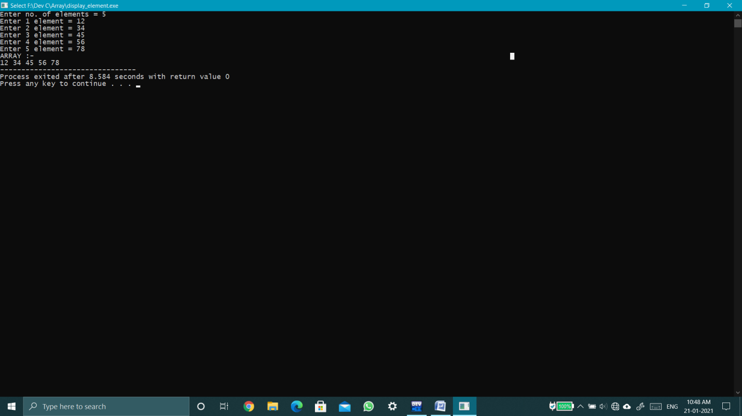

**Q2. WAP to input n elements in an array and display them in reverse order.**

**Soln.** #include<stdio.h>

int main()

{

int n;

printf("Enter no. of elements = ");

scanf("%d",&n);

int arr[n];

for(int i=0;i<n;i++)

{

printf("Enter %d element = ",i+1);

scanf("%d",&arr[i]);

}

printf("ARRAY :-\n");

for(int i=n-1;i>=0;i--)

{

printf("%d ",arr[i]);

}

}

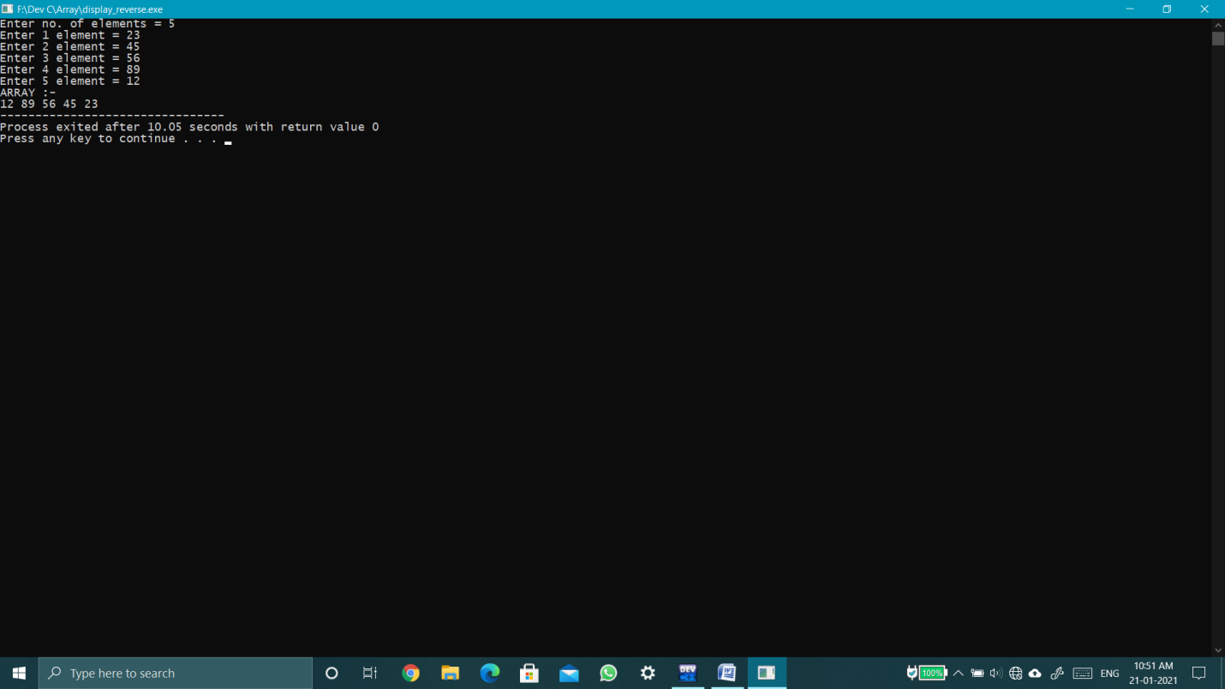

**Q3.WAP to input an array and display no. of +ve,-ve & zero no.**

**Soln.** #include<stdio.h>

int main()

{

int n;

printf("Enter no. of elements = ");

scanf("%d",&n);

int arr[n],p=0,N=0,z=0;

for(int i=0;i<n;i++)

{

printf("Enter %d element = ",i+1);

scanf("%d",&arr[i]);

if(arr[i]>0)

p++;

else if(arr[i]<0)

N++;

else

z++;

}

printf("Total Positive no. = %d\nTotal Negative no. = %d\nTotal zero no. = %d",p,N,z);

}

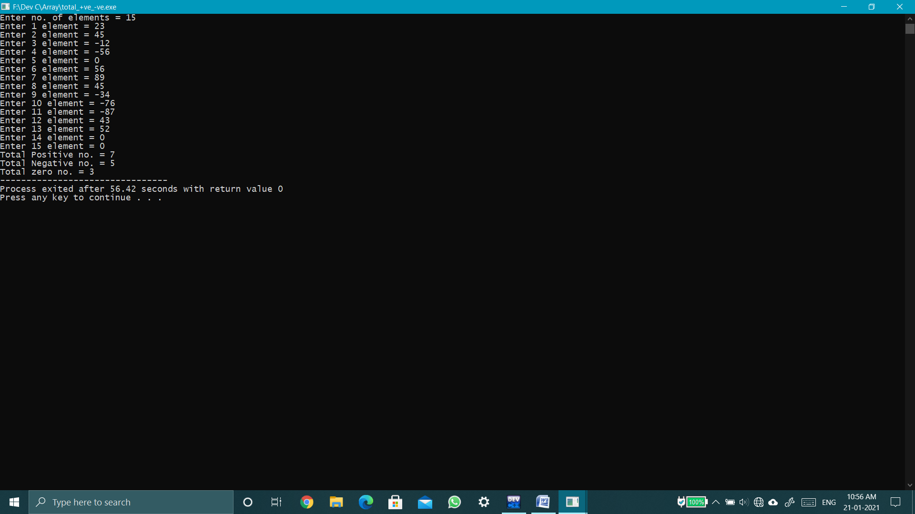

**Q4. WAP to input an array & display all even no. in one array and odd no. in another array.**

**Soln.** #include<stdio.h>

int main()

{

int n;

printf("Enter no. of elements = ");

scanf("%d",&n);

int a[n],o[n],e[n],odd=0,even=0;

for(int i=0;i<n;i++)

{

printf("Enter %d element = ",i+1);

scanf("%d",&a[i]);

if(a[i]%2==0)

{

e[even]=a[i];

even++;

}

else

{

o[odd]=a[i];

odd++;

}

}

printf("Odd Array\n");

for(int i=0;i<odd;i++)

printf("%d ",o[i]);

printf("\nEven Array\n");

for(int i=0;i<even;i++)

printf("%d ",e[i]);

}

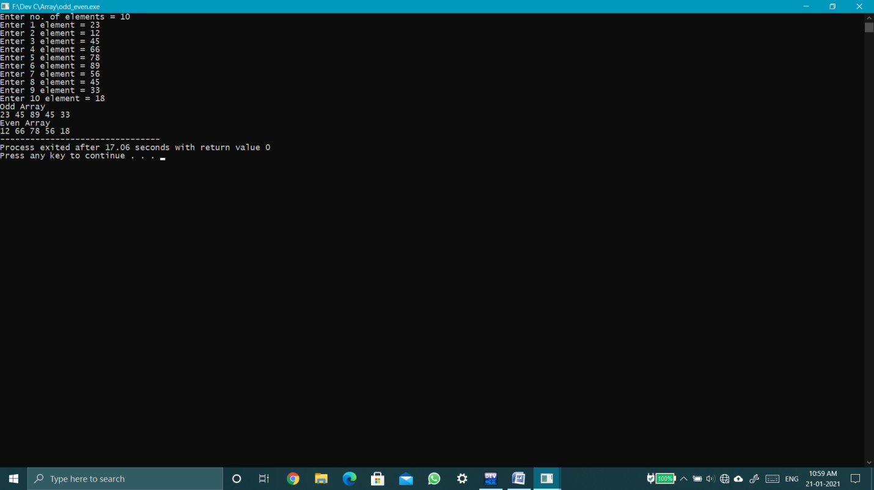

**Q5. Suppose there are election in us & there are two candidate ‘Donald Trump’ & ‘Joe Biden’ input the votes of 10 states in us & print state wise winner & overall winner.**

**Soln.** #include<stdio.h>

int main()

{

int t[10],b[10],et=0,eb=0,sumt=0,sumb=0,n=10;

for(int i=0;i<n;i++)

{

printf("Enter Votes of %d state = ",i+1);

scanf("%d %d",&t[i],&b[i]);

sumt+=t[i];

sumb+=b[i];

}

for(int i=0;i<n;i++)

{

if(t[i]>b[i]){

et++;

printf("Trump wins in state %d\n",i+1);

}

else if(b[i]>t[i]){

eb++;

printf("Biden wins in state %d\n",i+1);

}

else

{

printf("Draw in state %d\n",i+1);

}

}

printf("\n");

if(eb>et)

printf("BIDEN WINS");

else if(et>eb)

printf("TRUMP WINS");

else

{

if(sumt>sumb){

printf("TRUMP WINS");

}

else{

printf("BIDEN WINS");

}

}

}

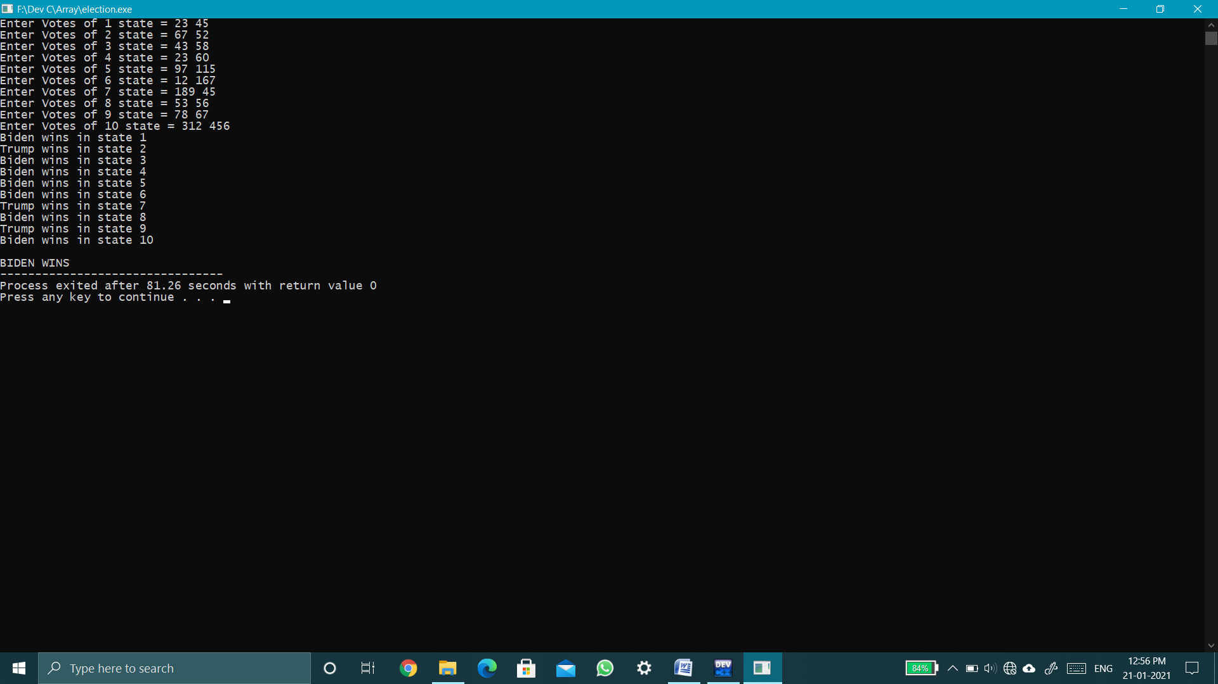

**Q6. WAP to find the binary equivalent of entered decimal no. using array.**

**Soln.**#include<stdio.h>

int main()

{

int n,i;

int binary[64];

scanf("%d",&n);

for(i=0;n>0;i++)

{

binary[i] = n%2;

n = n/2;

}

while(i--)

{

printf("%d",binary[i]);

} }

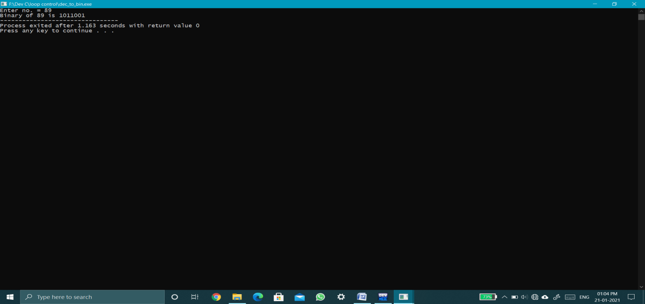

**Q7. WAP to input array and find Standard deviation(SD) of all no.**

**Soln.** #include<stdio.h>

#include<math.h>

int main()

{

int n;

printf("Enter no. of inputs = ");

scanf("%d",&n);

printf("\n");

int a[n],mean=0;

for(int i=0;i<n;i++)

{

printf("Enter %d no. = ",i+1);

scanf("%d",&a[i]);

mean += a[i];

}

mean/=n;

float sd=0;

for(int i=0;i<n;i++)

{

sd += pow(a[i]-mean,2);

}

sd/=n;

sd = sqrt(sd);

printf("\nStandard deviation = %.2f",sd);

}

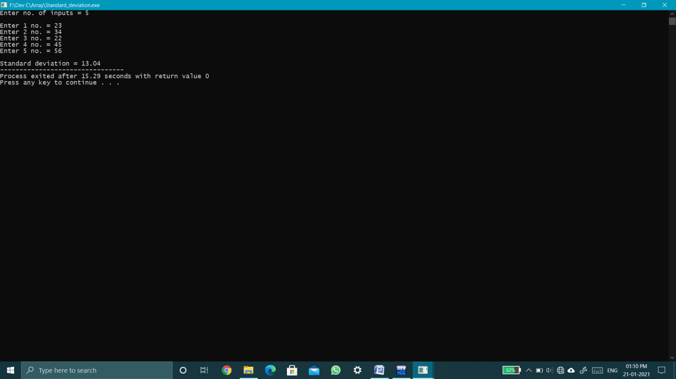

**Q8.WAP to input the marks of 15 students in Computer programming out of 10 & print the frequency of each score above 5.**

**Soln.** #include<stdio.h>

int main()

{

int freq[5]={0};

for(int i=1;i<=15;i++)

{

int mark;

printf("Enter marks of %d student = ",i);

scanf("%d",&mark);

if(mark>5)

freq[mark-6]++;

}

for(int i=0;i<5;i++)

{

printf("%d occurs %d times.\n",i+6,freq[i]);

}

}

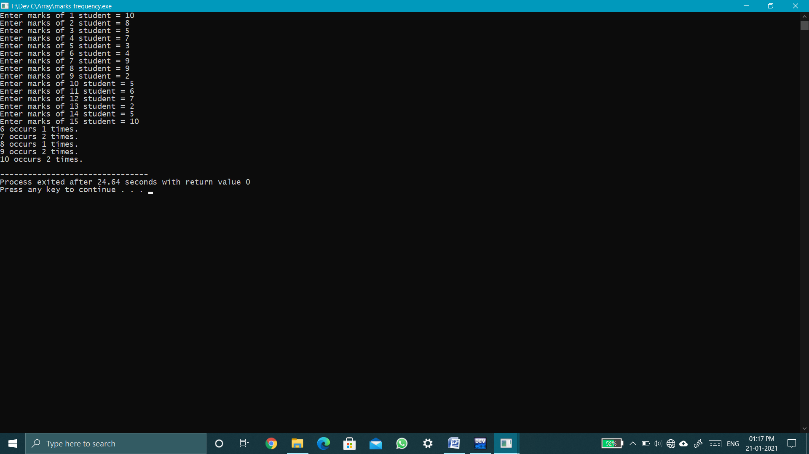

**Q9. WAP to enter an array and find maximum and minimum element and swap them.**

**Soln.** #include<stdio.h>

int main()

{

int n;

printf("Enter no. of elements = ");

scanf("%d",&n);

int arr[n],max,min,posx=0,posn=0;

for(int i=0;i<n;i++)

{

printf("Enter %d element = ",i+1);

scanf("%d",&arr[i]);

if(i==0){

max=arr[i];

min=arr[i];

}

if(arr[i]>max)

{

max=arr[i];

posx=i;

}

if(arr[i]<min)

{

min=arr[i];

posn=i;

}

}

arr[posx]+=arr[posn];

arr[posn]=arr[posx]-arr[posn];

arr[posx]-=arr[posn];

for(int i=0;i<n;i++)

{

printf("%d ",arr[i]);

}

}

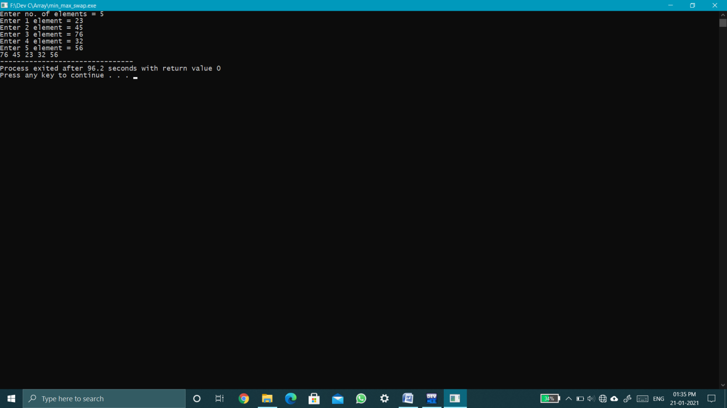

**Q10. WAP to input an array and find maximum and Second maximum in array.  
Soln.** #include<stdio.h>

int main()

{

int n;

printf("Enter no. of elements = ");

scanf("%d",&n);

int a[n],max,smax;

for(int i=0;i<n;i++)

{

printf("Enter %d no.= ",i+1);

scanf("%d",&a[i]);

}

max=a[0];

smax=a[0];

for(int i=0;i<n;i++)

{

if(a[i]>max)

{

smax=max;

max=a[i];

}

else if(a[i]>smax && a[i]!=max)

smax=a[i];

}

printf("Max = %d\nSecond Max = %d",max,smax);

}

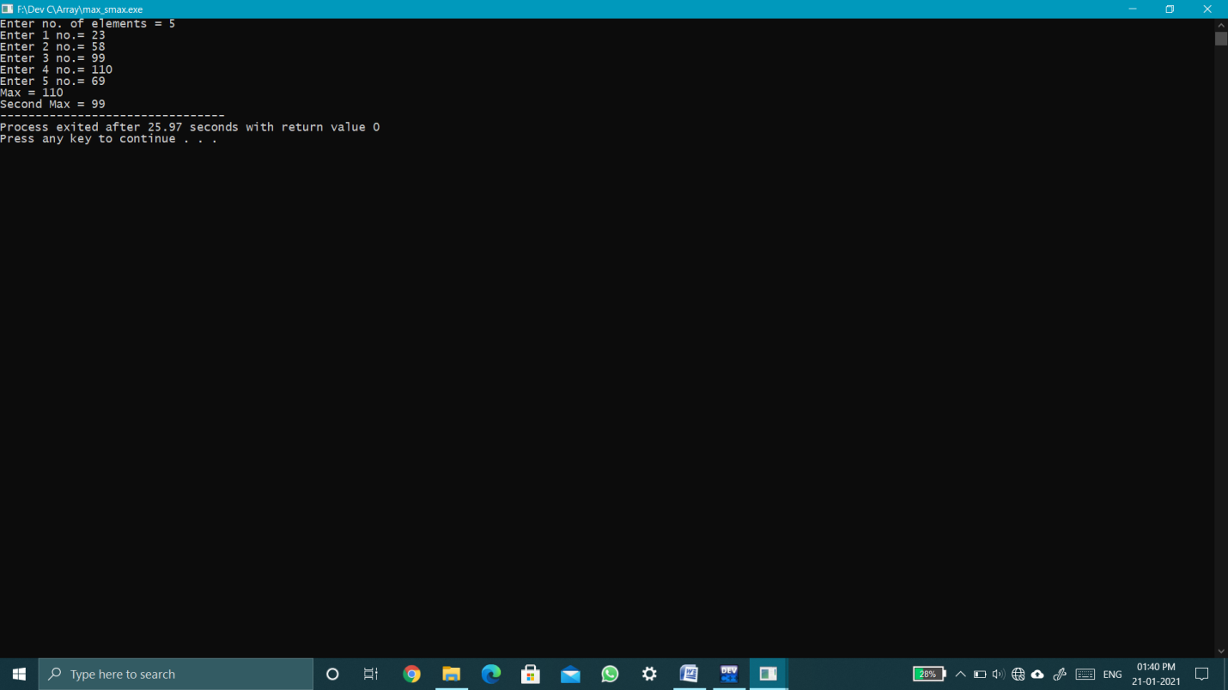

**Q11.WAP to input an array and find average of that array.**

**Soln.** #include<stdio.h>

int main()

{

int n;

printf("Enter no. of inputs = ");

scanf("%d",&n);

printf("\n");

float avg=0,a[n];

for(int i=0;i<n;i++)

{

printf("Enter %d no. = ",i+1);

scanf("%f",&a[i]);

avg += a[i];

}

avg/=n;

printf("Average = %.2f",avg);

}

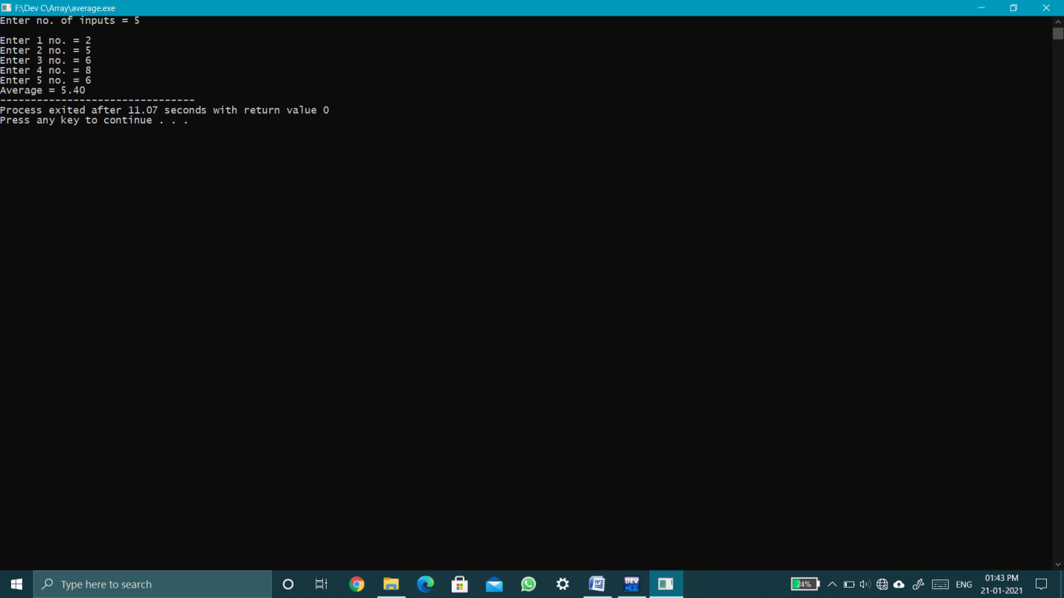

**Q12. WAP to input an array and search for desired element.**

**Soln.** #include<stdio.h>

int main()

{

int n;

printf("Enter no. of elements = ");

scanf("%d",&n);

int arr[n];

for(int i=0;i<n;i++)

{

printf("Enter %d element = ",i+1);

scanf("%d",&arr[i]);

}

int no,f=0;

printf("Enter no. to search = ");

scanf("%d",&no);

for(int i=0;i<n;i++)

{

if(arr[i]==no){

f=1;

printf("%d find at %d position.\n",no,i+1);

}

}

if(f==0)

printf("%d Not Found.\n",no);

}

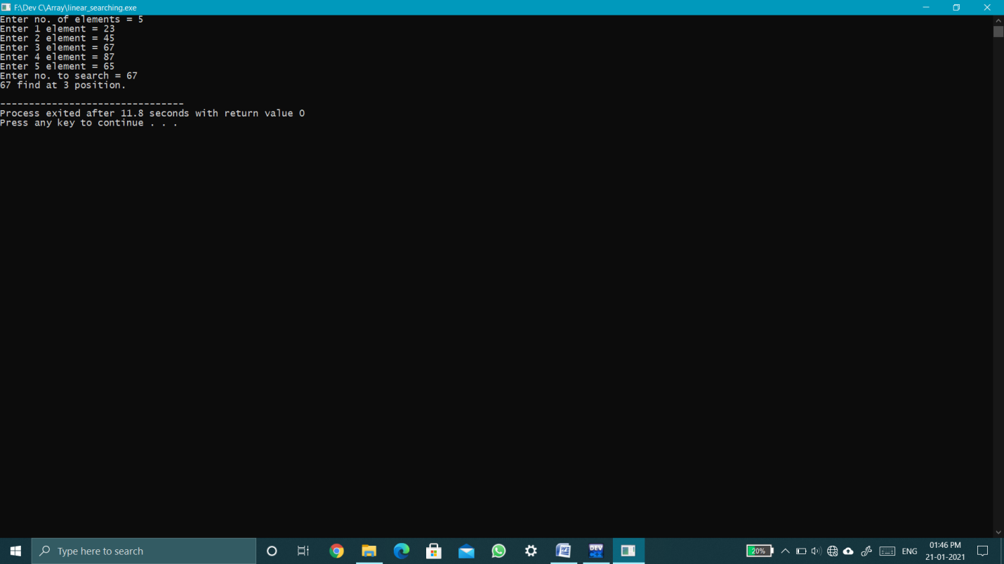

**Q13. WAP to input an array and perform left rotation by r no. of rotation.**

**Soln.** #include<stdio.h>

int main()

{

int n;

printf("Enter no. of elements = ");

scanf("%d",&n);

int arr[n];

for(int i=0;i<n;i++)

{

printf("Enter %d element = ",i+1);

scanf("%d",&arr[i]);

}

int r;

printf("Enter no. of rotation = ");

scanf("%d",&r);

r = r>n?r%n:r;

for(int i=1;i<=r;i++)

{

int temp;

for(int j=0;j<n;j++)

{

if(j==0)

{

temp=arr[0];

}

arr[j]=arr[j+1];

}

arr[n-1]=temp;

}

for(int i=0;i<n;i++)

printf("%d ",arr[i]);

}

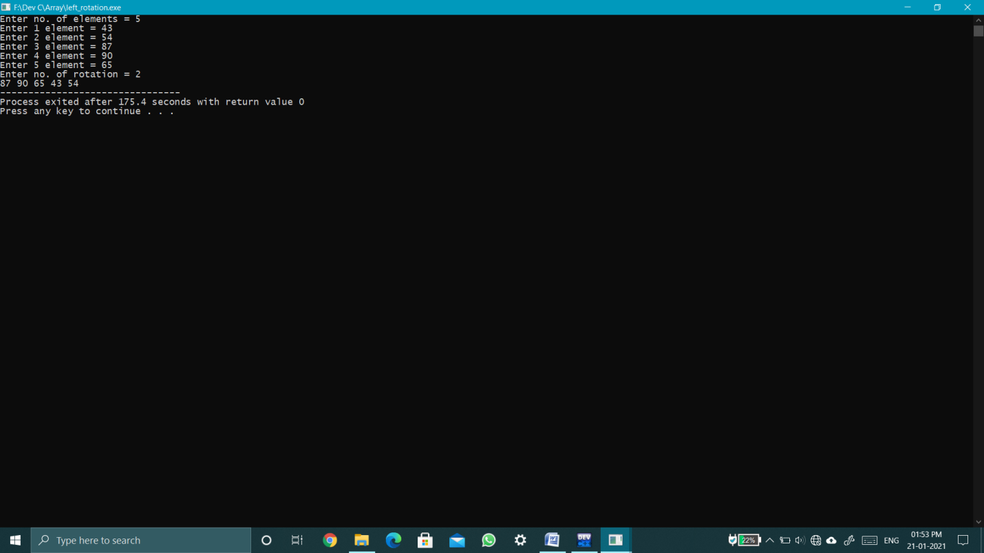

**Q14. WAP to input an array and perform right rotation by r no. of rotation.**

**Soln.** #include<stdio.h>

int main()

{

int n;

printf("Enter no. of elements = ");

scanf("%d",&n);

int arr[n];

for(int i=0;i<n;i++)

{

printf("Enter %d element = ",i+1);

scanf("%d",&arr[i]);

}

int r;

printf("Enter no. of rotation = ");

scanf("%d",&r);

r = r>n?r%n:r;

for(int i=1;i<=r;i++)

{

int temp;

for(int j=n-1;j>0;j--)

{

if(j==n-1)

{

temp = arr[n-1];

}

arr[j]=arr[j-1];

}

arr[0]=temp;

}

for(int i=0;i<n;i++)

printf("%d ",arr[i]);

}

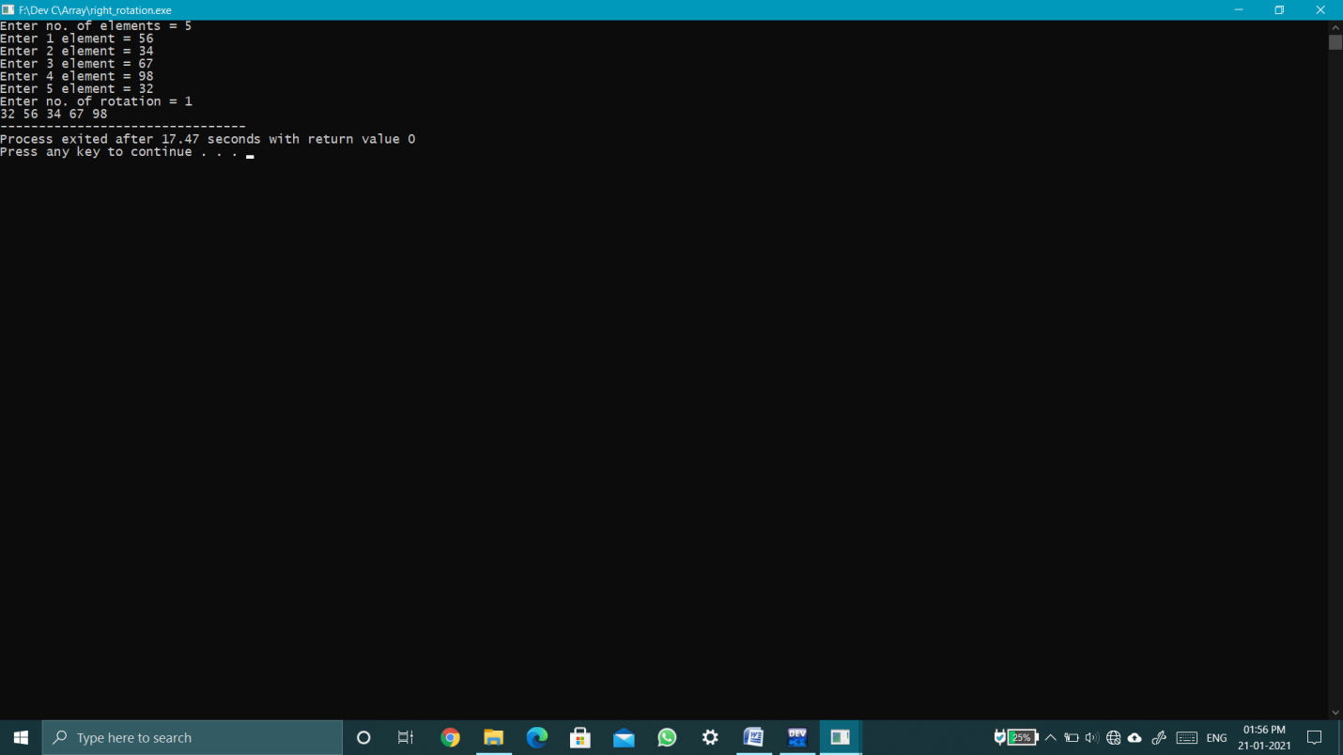

**Q15. Suppose there are 2 sections A and B.Wehave exam of computer programming and students of same rollno. From both the sections are sitting together on a particular seat and hence they do cheating in exam.**

**Input marks of students in section A and find marks of students of section B.**

**Soln.** #include<stdio.h>

int main()

{

int n;

printf("Enter no. of students in section A = ");

scanf("%d",&n);

int a[n],b[n];

for(int i=0;i<n;i++)

{

printf("Enter marks of Roll no. %d = ",i+1);

scanf("%d",&a[i]);

b[i]=a[i];

}

for(int i=0;i<n;i++)

{

printf("Marks of Roll no. %d of section B = %d\n",i+1,b[i]);

}

}

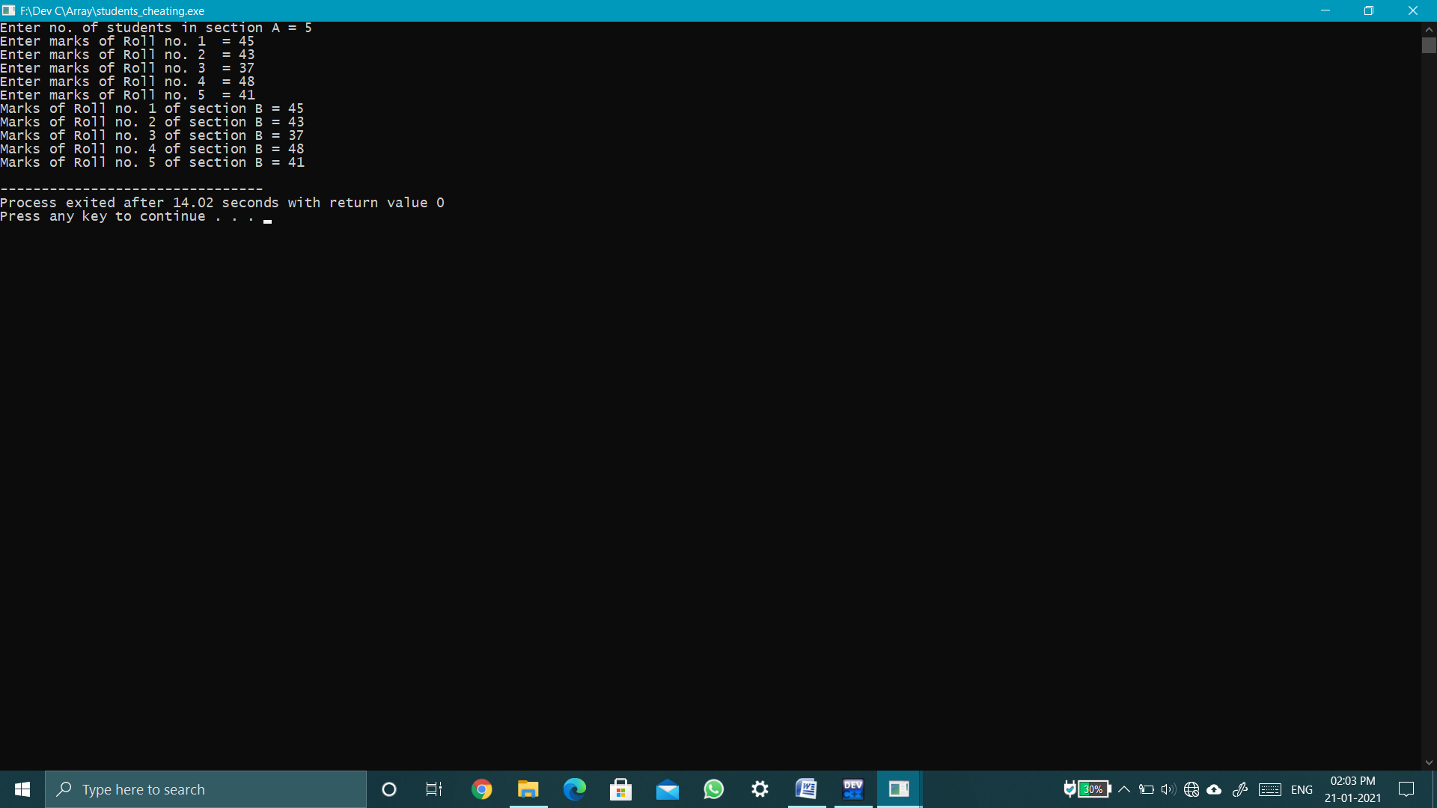

**Q16. WAP to input an array and find the frequency of a particular element in that array.**

**Soln.** #include<stdio.h>

int main()

{

int n;

printf("Enter no. of elements = ");

scanf("%d",&n);

int arr[n];

for(int i=0;i<n;i++)

{

printf("Enter %d element = ",i+1);

scanf("%d",&arr[i]);

}

int no,f=0;

printf("Enter no. to find its fequency = ");

scanf("%d",&no);

for(int i=0;i<n;i++)

{

if(arr[i]==no)

f++;

}

printf("%d occurs %d times.",no,f);

}

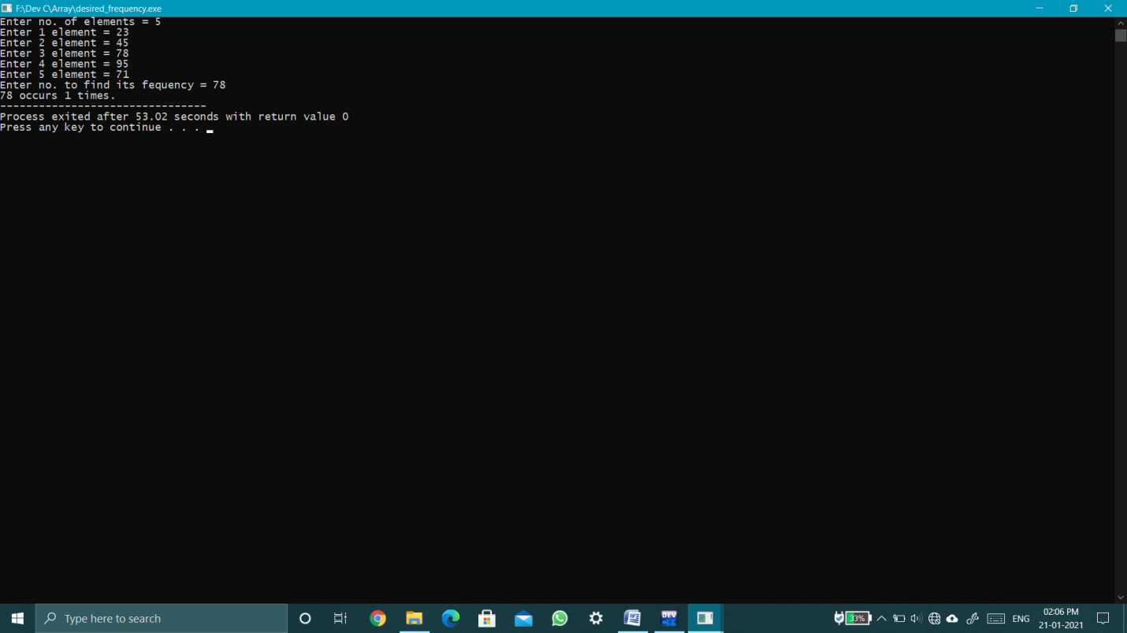

**Q17.WAP to input an array and find the frequency of each element in that array.**

**Soln.** **#include<stdio.h>**

**int main()**

**{**

**int n;**

**printf("Enter no. of elements. = ");**

**scanf("%d",&n);**

**int a[n];**

**for(int i=0;i<n;i++)**

**{**

**printf("Enter %d no. = ",i+1);**

**scanf("%d",&a[i]);**

**}**

**for(int i=1;i<=n;i++)**

**{**

**for(int j=0;j<n-i;j++)**

**{**

**if(a[j]>a[j+1])**

**{**

**int temp = a[j];**

**a[j]=a[j+1];**

**a[j+1]=temp;**

**}**

**}**

**}**

**for(int i=0;i<n;)**

**{**

**int ele=a[i],temp=a[i],c=0;**

**while(ele == a[i])**

**{**

**c++;**

**ele=a[i+c];**

**}**

**i+=c;**

**printf("%d occurs %d times.\n",temp,c);**

**}**

**}**

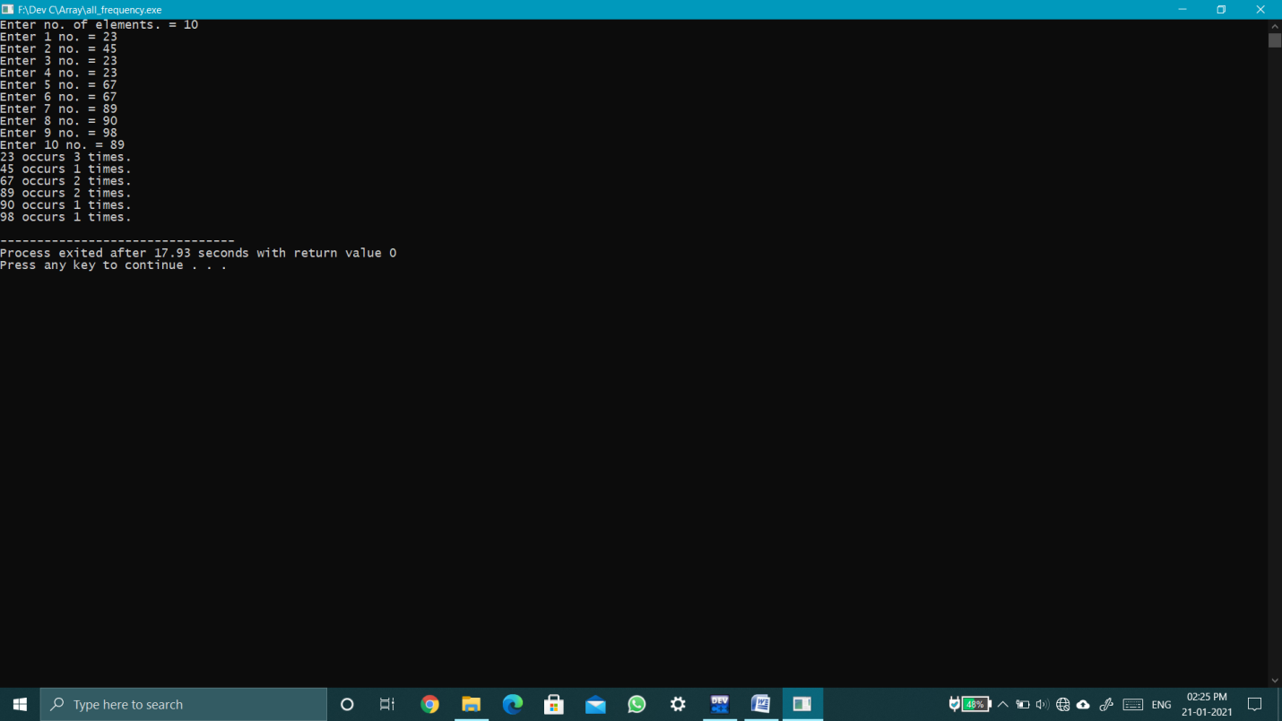

**Q18.WAP to input an array of N elements and convert all prime numbers into next palindrome number and convert all composite numbers into their next Armstrong number.Hence, Print the updated array.**

**Soln.** #include<stdio.h>

#include<math.h>

int pallindrome(int n)

{

for(int i=n+1;;i++)

{

int temp=i,sum=0;

while(temp!=0)

{

sum = sum*10 + temp%10;

temp/=10;

}

if(sum==i)

return i;

}

}

int armstrong(int n)

{

for(int i=n+1;;i++)

{

int temp=i,c=0;

float arm=0;

while(temp!=0)

{

c++;

temp/=10;

}

temp=i;

while(temp!=0)

{

arm += pow(temp%10,c);

temp/=10;

}

if(arm==i)

return i;

}

}

int chk_prime(int n)

{

int f=0;

for(int i=2;i<=n/2;i++)

{

if(n%i==0)

{

f=1;

break;

}

}

if(f==0)

return 1;

else

return 0;

}

int main()

{

int n;

printf("Enter no. of elements = ");

scanf("%d",&n);

int a[n];

for(int i=0;i<n;i++)

{

printf("Enter %d no.= ",i+1);

scanf("%d",&a[i]);

}

for(int i=0;i<n;i++)

{

int f = chk_prime(a[i]);

if(f==1)

{

a[i] = pallindrome(a[i]);

}

else if(f==0){

a[i] = armstrong(a[i]);

}

printf("%d ",a[i]);

}

}

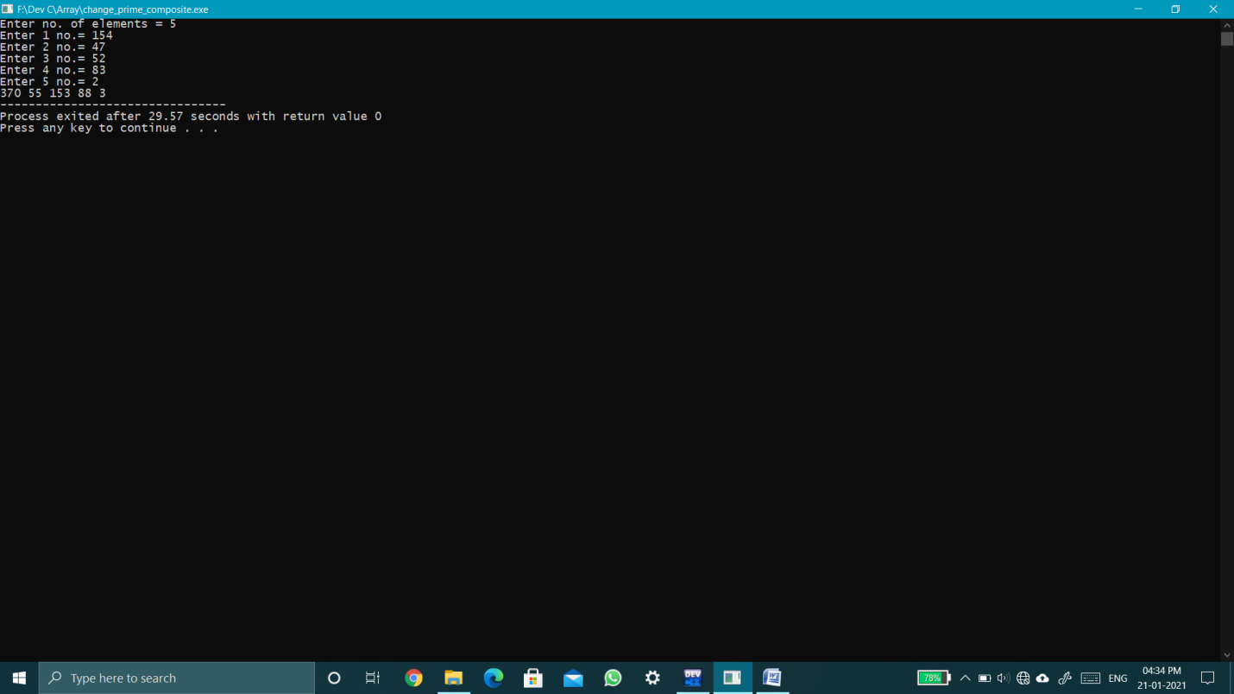

**Q19. WAP to input an array of N number of elements and find the largest element in that array.**

**Soln.** #include<stdio.h>

int main()

{

int n;

printf("Enter no. of elements = ");

scanf("%d",&n);

int arr[n],max=0;

for(int i=0;i<n;i++)

{

printf("Enter %d element = ",i+1);

scanf("%d",&arr[i]);

if(arr[i]>max)

{

max=arr[i];

}

}

printf("Largest element = %d",max);

}

**Q20. WAP to input an array of N number of elements and find the smallest element in that array.**

**Soln.** #include<stdio.h>

int main()

{

int n;

printf("Enter no. of elements = ");

scanf("%d",&n);

int arr[n],min=99999;

for(int i=0;i<n;i++)

{

printf("Enter %d element = ",i+1);

scanf("%d",&arr[i]);

if(arr[i]<min)

{

min=arr[i];

}

}

printf("Smallest element = %d",min);

}

**Q21.** **WAP to input an array of N number of elements and find the second smallest element and 2nd largest element in that array.**

**Soln.** #include<stdio.h>

int main()

{

int n;

printf("Enter no. of elements = ");

scanf("%d",&n);

int a[n],max,smax,min,smin;

for(int i=0;i<n;i++)

{

printf("Enter %d no.= ",i+1);

scanf("%d",&a[i]);

}

max=a[0];

smax=a[0];

min=a[0];

smin=a[0];

for(int i=0;i<n;i++)

{

if(a[i]>max)

{

smax=max;

max=a[i];

}

else if(a[i]>smax && a[i]!=max)

smax=a[i];

if(a[i]<min)

{

smin=min;

min=a[i];

}

else if(a[i]<smin && a[i]!=min)

smin=a[i];

}

printf("Second Min = %d\nSecond Max = %d",smin,smax);

}

**Q22.** **WAP to input an array of N number of elements and sort it in ascending order using bubble sort.**

**Soln.** #include<stdio.h>

int bubblesort(int a[],int n)

{

for(int j=1;j<n;j++)

{

for(int i=0;i<n-j;i++)

{

if(a[i]>a[i+1])

{

int t=a[i];

a[i]=a[i+1];

a[i+1]=t;

}

}

}

return 0;

}

int main()

{

int a[20],n;

printf("Enter no. of elements to be insert = ");

scanf("%d",&n);

for(int i=0;i<n;i++)

{

printf("Enter value -> ");

scanf("%d",&a[i]);

}

bubblesort(a,n);

printf("In Ascending order:-\n");

for(int i=0;i<n;i++)

{

printf("%d ",a[i]);

}

return 0;

}

**Q23.** **WAP to input an array of N number of elements and sort it in Descending order using bubble sort.**

**Soln.** #include<stdio.h>

int bubblesort(int a[],int n)

{

for(int j=1;j<n;j++)

{

for(int i=0;i<n-j;i++)

{

if(a[i]<a[i+1])

{

int t=a[i];

a[i]=a[i+1];

a[i+1]=t;

}

}

}

return 0;

}

int main()

{

int a[20],n;

printf("Enter no. of elements to be insert = ");

scanf("%d",&n);

for(int i=0;i<n;i++)

{

printf("Enter value -> ");

scanf("%d",&a[i]);

}

bubblesort(a,n);

printf("In Ascending order:-\n");

for(int i=0;i<n;i++)

{

printf("%d ",a[i]);

}

return 0;

}

**Q24. WAP to input an array of N number of elements. Input an element you want to insert in that array along with the position and insert it. Print the final array after insertion.**

**Soln.** #include<stdio.h>

int insdes(int a[],int n,int x,int pos)

{

for(int i=n;i>=pos;i--)

{

a[i]=a[i-1];

}

a[pos-1]=x;

n++;

return n;

}

void main()

{

int a[10],n,x,pos;

printf("Enter no. of elements to be insert =");

scanf("%d",&n);

for(int i=0;i<n;i++)

{

printf("Enter %d value = ",i+1);

scanf("%d",&a[i]);

}

printf("Enter value to be insert = ");

scanf("%d",&x);

printf("Enter position = ");

scanf("%d",&pos);

n=insdes(a,n,x,pos);

for(int i=0;i<n;i++)

{

printf("%d ",a[i]);

}

}

**Q25. WAP to input an array of N number of elements. Input the position of element you want to delete. Print the element deleted and updated array after deletion of that element.**

**Soln.** #include<stdio.h>

int deldes(int a[],int n,int x)

{

Int ele=a[x-1];

for(int i=x-1;i<n-1;i++)

{

a[i]=a[i+1];

}

Printf(“Deleted element = %d\n”,ele);

n--;

return n;

}

int main()

{

int a[10],n,x;

printf("Enter no. of elements to be insert =");

scanf("%d",&n);

for(int i=0;i<n;i++)

{

printf("Enter %d number = ",i+1);

scanf("%d",&a[i]);

}

printf("Enter position on which value is deleted =");

scanf("%d",&x);

n=deldes(a,n,x);

for(int i=0;i<n;i++)

{

printf("%d ",a[i]);

}

}

**Q26. WAP to input an array of N number of elements. Input the element you want to delete and delete the first occurrence of that element from that array. Print the updated array.**

**Soln.** #include <stdio.h>

int main() {

int n;

scanf("%d",&n);

double a[n];

for(int i=0;i<n;i++)

scanf("%lf ",&a[i]);

double val;

int f=0,pos;

scanf("%lf",&val);

for(int i=0;i<n;i++)

{

if(a[i]==val)

{

f=1;

pos=i;

break;

}

}

if(f==0)

printf("Not found.");

else{

for(int i=pos;i<n-1;i++)

{

a[i]=a[i+1];

}

n--;

for(int i=0;i<n;i++)

printf("%.0lf ",a[i]);

}

return 0;

}

**Q27. WAP to input an array of N number of elements. Input the element you want to delete and delete all occurrence of that element from that array. Print the updated array.**

**Soln.** #include <stdio.h>

int main() {

int n;

scanf("%d",&n);

int a[n];

for(int i=0;i<n;i++)

{

scanf("%d",&a[i]);

}

int x,f=0;

scanf("%d",&x);

for(int i=0;i<n;i++)

{

if(a[i]==x)

{

int pos =i+1;

for(int j=pos;j<n;j++)

a[j-1] = a[j];

n -= 1;

f = 1;

i--;

}

}

if(f == 1)

{

for(int i=0;i<n;i++)

printf("%d ",a[i]);

}

else

printf("Not found.");

return 0;

}

**Q28. Find the output of following .**

**a.) #include<stdio.h>**

|  |
| --- |
| **int main(){**  **int arr[5];**  **arr[0] = 5;**  **arr[2] = -10;**  **arr[3/2] = 2;**  **arr[3] = arr[0];**  **printf("%d %d %d %d", arr[0], arr[1], arr[2], arr[3]);**  **return 0;**  **}**  **Soln.** 52-105 |

**b.) #include<stdio.h>**

**int main(){**

**int arr[2] = {10, 20, 30, 40, 50};**

**printf("%d %d %d %d %d",arr[0],arr[1],arr[2],arr[3],arr[-1]);**

**return 0;**

**}**

**Soln.** 1020ggg

**c.) #include<stdio.h>**

**int main(){**

**int arr[10] = {1,2,3};**

**printf("%d %d %d %d",arr[0],arr[2],arr[4],arr[6]);**

**return 0;**

**}**

**Soln.**130 0

**Q29. Consider an array ar[7] -**

**12 67 45 34 87 90 23**

**What will be the contents of this array after execution of following code?**

**for(i=2; i<=5;i++)**

**ar[i]=ar[i+1];**

**Soln.** 12 67 34 87 90 23 23

**Q30. Consider an array ar[7] -**

**12 67 45 34 87 90 23**

**What will be the contents of this array after execution of following code?**

**for(i=7; i>=3;i--)**

**ar[i-1]=ar[i];**

**Soln.** 12 67 g g g g g

**Q31. What will be the output of following program?**

**int main(void) {**

**int i;**

**int a[5]={1,2,3,4,5};**

**for(i=5;i>=2;i--)**

**a[i-1]=a[i-2];**

**for(i=0;i<5;i++)**

**printf("%d ",a[i]);**

**return 0;**

**}**

**Soln.** 1 1 2 3 4

**Q32. What will be the output of following program?**

**int main(void) {**

**int i;**

**int a[5]={1,2,3,4,5};**

**for(i=5;i>=2;i--)**

**a[i+1]=a[i-2];**

**for(i=0;i<5;i++)**

**printf("%d ",a[i]);**

**return 0;**

**}**

**Soln.** 1 2 3 1 2

**Q33. Consider an array [8] containing following elements-**

**12, 5, 17, 87, 109, 43, 44, 47**

**Show the process of bubble sort on this array.**

**Soln. Pass 1 –** 5, 12, 17, 87, 43, 44, 47, 109 (109 is bubbled)

**Pass 2-** 5, 12, 17, 43, 44, 47, 87, 109 (87 &109 are bubbled)

Although array is sorted by algorithm continue till pass 7.

**Q34. Assume an array consists of following elements-**

**19 45 67 78 89 56**

**Apply linear search algorithm to search the element 78 on this array.**

**Soln. Search 1 –** 19 not equal 78 loop continues.

**Search 2 –** 45 not equal 78 loop continues.

**Search 3 –** 67 not equal 78 loop continues.

**Search 4 –** 78 equal to 78 loop terminate and return position of 78.

**Q35. WAP to input an array of N elements and delete all the elements from that array which are perfect number.**

**Soln.** #include<stdio.h>

int main()

{

int a[1000],i,n,j=0,count=0,pos,sum=0,k=0;

printf("Enter the no of elements in the array ");

scanf("%d",&n);

int b=n;

printf("Enter the elements of the array ");

for(i=0;i<=n-1;i++)

{

scanf("%d",&a[i]);

}

while(b>0)

{

for(i=0;i<=n-1;i++)

{

for (j=1;j<a[i];j++)

{

if(a[i]%j==0)

sum=sum+j;

}

if(sum==a[i])

{

count++;

pos=i;

for(k=pos;k<=n-1;k++)

{

a[k]=a[k+1];

}

n=n-count;

}

sum=0;

count=0;

}

b--;

}

for(i=0;i<=n-1;i++)

{

printf("%d ",a[i]);

}

}

**Q36. WAP to input an array of N number of elements and delete all the duplicate elements from that array.**

**Soln.** #include"stdio.h"

int main()

{

int a[1000],i,n,j,pos,count=0,k;

printf("Enter the no of elements in the array ");

scanf("%d",&n);

int b=n;

printf("Enter the elements of the array ");

for(i=0;i<=n-1;i++)

{

scanf("%d",&a[i]);

}

while(b>0)

{

for(i=0;i<=n-1;i++)

{

for(j=i+1;j<=n-1;j++)

{

if(a[j]==a[i])

{

count++;

pos=j;

for(k=pos;k<=n-1;k++)

{

a[k]=a[k+1];

}

n=n-count;

}

count=0;

}

}

b--;

}

for(i=0;i<=n-1;i++)

{

printf("%d ",a[i]);

}

}

**Q37. Write a program in ‘C’ to store (in an array) and print the roll numbers of students beginning from m to n.**

**Soln.** #include<stdio.h>

int main()

{

int n,m;

printf("Enter no. of students = ");

scanf("%d",&n);

long long int roll[n];

for(int i=0;i<n;i++)

{

printf("Enter rollno. of %d student = ",i+1);

scanf("%lld",&roll[i]);

}

printf("Enter no. from which you want rollno. = ");

scanf("%d",&m);

for(int i=m-1;i<n;i++)

{

printf("Rollno. of %d student = %lld\n",i+1,roll[i]);

}

}